Paper No: 05-IAGT-3.3  Industrial Application of  Gas Turbines Committee | 

Noise Control engineering Objectives
for compressor station turbo-compressor units
by

Leslie Frank, M.Sc., P.Eng., P.E.
of
HFP Acoustical Consultants Corp.
Calgary, AB, Canada

Leslie Frank, M.S., P.Eng., P.E., President of HFP Acoustical Consultants Corp., Calgary, AB, Canada, specializes in conducting environmental noise impact assessments and managing engineering noise control design studies, and is a recognized international expert in the area of acoustics and noise control for the oil, gas, and petrochemical industry. Mr. Frank’s clientele include the majority of the natural gas transmission pipeline companies within Canada and throughout the United States; owner/operators of major gas processing plants, refineries, petrochemical plants, cogeneration plants and power plants, and previously the Pipeline Research Committee International of the American Gas Association. His master’s degree is in Engineering Acoustics from Penn State. He was recently awarded the 2005 Alumnus of the Year Anchor Award for the College of Engineering from the University of Hartford.
Abstract

Noise control engineering for natural gas compressor station turbo-compressor units can be performed in many different ways, with various design strategies, all having differing degrees of cost effectiveness, effect on unit performance, and effect on ease of operations. In addition to assessing these variables, various noise control design strategies also have greatly differing degrees of acoustical performance. These acoustical parameters can be optimized with the advent of computer noise modeling, which enhances the ability to reduce environmental noise related complaints from nearby neighbours and to meet regulatory targets.

One example of the above is the design alternative of using acoustical unit enclosures or acoustical rated compressor buildings. Close fitting acoustical unit enclosures provide a significant reduction of casing radiated noise from the gas turbine driver, which is beneficial for both operations personnel inside the compressor building, as well the enclosure reduces some environmental radiated noise. Conversely an acoustical rated compressor building can easily provide greater degrees of environmental benefit, and while the in-plant sound levels are higher, maintenance personnel save valuable time by not having to knock down enclosure walls. While unit enclosures generally provide between 20 to 25 dBA of noise reduction, their benefit is limited to just reducing the noise from the gas turbine casing. Alternatively, acoustical rated buildings generally provide greater than 30 dBA of noise reduction, and their benefit is also available to control noise from other sources such as interior piping and lube oil cooling skids. Both unit enclosures and acoustical rated buildings require silenced ventilation systems in differing proportions.

However noise source contributions from other mechanical equipment components also need to be reduced in balanced proportions to notice the effect of the casing radiated noise component as reduced by unit enclosures or acoustical rated buildings. Dominance of the gas turbine’s casing radiated noise contribution as compared to the power turbine’s exhaust noise contribution usually diminishes at distances greater than one-half of a kilometer away. Then for residences more than two kilometers away, the exhaust noise contribution is usually the sole remaining contributor. This infers that balancing the exhaust silencer’s performance with the casing noise reduction provides various economically balanced alternatives. Computer noise modeling clearly demonstrates these effects for various degrees of benefit of each, yielding a total acoustical balanced design.

Differing regulatory targets for compressor station noise control for the Canadian and American natural gas transmission industry will be presented. The typical strategy to achieve compliance to these targets, utilizing the balanced noise control design approach, will be suggested. The use of computer noise modeling as a tool to test these conceptual designs will be demonstrated through graphical presentations.
Table of Contents

Noise Control Assessment Phases 1

Phase 1 – Determine Regulatory Requirements – environmental and in-plant 1

Phase 2 – Identify Noise Sources 3

Phase 3 – Predict Facility Noise Contributions – computer noise modeling 4

Phase 4 – Design Noise Control Mitigation – specialty materials and systems 8

Phase 5 – Assess Cost-Effective Solutions – not interfering with operations and safety 9

Phase 6 – Compliance 10

Noise Control Optimization 11

Acoustical Unit Enclosures vs. Acoustical Rated Compressor Buildings 11

Balanced Noise Control Proportions 13

Strategies to Achieve Compliance to Regulatory Targets 15

Drawbacks to Successful Implementation 16

Be Aware Of Individual Sensitivities 16

The Myth of 85 dBA 16

Don't Specify Without Acoustical Performance Guarantee 17

Management Buy-in 18

Conclusions 18

Noise Control Assessment Phases

Designing for and achieving noise control incorporates complex procedures which can be handled as a separate design discipline. While this paper concentrates on turbo-compressor units at natural gas compressor stations, this concept is also relevant at pipeline compressor stations, pipeline straddle (gas processing) plants, LNG receiving (regasification) terminals, or almost any other place where rotating equipment is used. These procedures depicted herein apply to retrofit projects at existing facilities, when adding new units at existing facilities, and for designing new facilities. Successful implementation of noise control engineering can be achieved by following the six phases as described in this paper.

Phase 1 – Determine Regulatory Requirements - environmental and in-plant: Noise control is crucial in today’s society to achieve compliance with environmental and workplace regulations. Canadian regulators such as the Alberta Energy and Utilities Board (EUB) and the Ontario Ministry of the Environment (MOE) regulate energy industry noise at nearby residences. Most regulated facilities must comply with the maximum facility sound level contribution between 40 to 50 dBA L_{eq} at the nearby residences. For exceptional cases like a pristine environment, the Alberta EUB may allow a pre-construction sound level survey, which might make the permissible sound levels more stringent. Similarly, the U.S. Federal Energy Regulatory Commission (FERC) and other American regulatory agencies detail the maximum permissible sound level at residential Noise Sensitive Areas (NSA’s). Here, most regulated facilities must comply with the maximum facility sound level contribution around 55 dBA L_{dn} at all NSA's, which is measured using EPA’s day-night energy average sound level. This value approximates a steady sound level of around 48½ dBA L_{eq}, which for reference purposes, is analogous to the sound level from a clothes dryer at home. FERC also requires a pre-construction sound level survey to quantify the existing acoustical environment surrounding the proposed site. Other federal, provincial, state, or local regulatory agencies may have additional and even overlapping sound level requirements.

Detailed sound level predictions are often required during the design phase, and regulatory compliance sound level measurements are usually required immediately after facility commissioning. For example, for compressor stations, the most stringent designs are usually when older compressor units exist, and the newer unit may need to be designed to be significantly quieter, such that the total site noise does not exceed requirements. In these cases, predictions of the sound level contribution of the proposed unit are added to the existing sound levels in the area to determine the overall future sound levels surrounding the station.

Noise control is equally crucial in today’s society to provide a quiet in-plant workplace environment as part of a hearing conservation program relative to minimizing the risk of occupational hearing loss. The U.S. Occupational Safety and Health Administration (OSHA) and other regulatory agencies detail the maximum workplace sound level at work-station locations. Their time-averaged sound level per work-station should not exceed 85 dBA. In recent years, simply presuming hearing protection will be provided and not providing engineering controls is not deemed as an acceptable practice. The ability to work without hearing protection is often viewed essential for worker productivity and comfort. Therefore, design teams are being held accountable to demonstrate due diligence by providing engineering noise controls wherever practicable to meet workplace regulatory requirements. For example, blowdown silencers and PSV vent silencers are often designed with adequate noise control to meet the condition that an operator might be nearby when the venting occurs.

Phase 2 – Identify Noise Sources: Previous design experience indicates that typical noisy mechanical, rotating and process equipment at pipeline and gas processing facilities with turbo-compressor packages includes the following:
- Compressor casing | - Compressor suction and discharge piping
- Power turbine casing | - Compressor recycle piping
- Combustion air inlet | - Suction scrubber
- Power turbine exhaust | - Process control valves
- Gas blowdown vents | - Flares
  - Compressor building ventilation – air inlet louvers
  - Compressor building ventilation – air outlet vents
  - Unit enclosure ventilation outlets
  - Air cooled exchangers (fin-fan coolers)

Compressor station equipment, which is largely responsible for environmental and in-plant noise radiation, needs to be broken down into its noise-radiating sub-components. For example, noise-radiating sub-components for compressors include suction and discharge piping (including inter-stage piping), compressor nozzles, compressor casings and silencer casings. Similarly, equipment sub-components for gas turbines include the gas generator and power turbine casing, enclosure cooling air blowers, combustion air inlets, and exhaust sub-components include ductwork, silencer casings and the silenced combustion exhaust outlet. Finally, sub-components for compressor buildings include building noise radiation from wall panels and roof decks, as well as through air inlet and exhaust louvers.

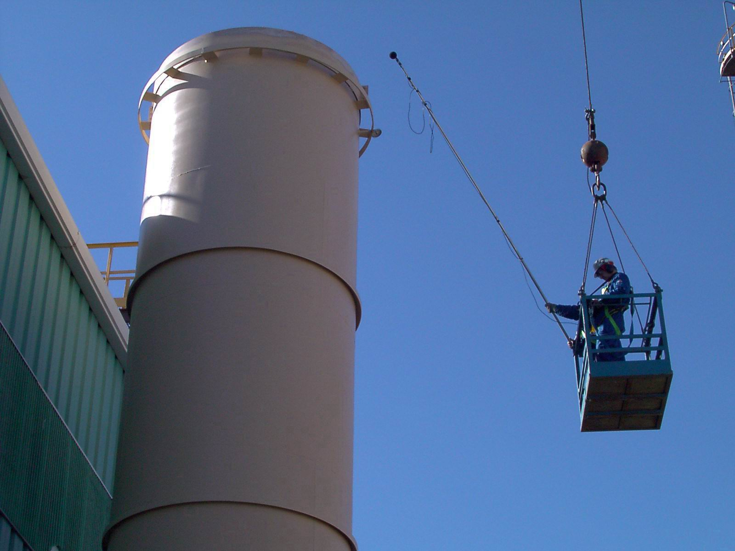
It is very important to identify the particular equipment sub-components that will radiate noise for a proposed retrofit or new design. Missing just one could be devastating. Then, one must obtain, measure or calculate the acoustical energy that each equipment sub-component will radiate, which is most
quantified in terms of Sound Power Levels. A noise source which is easy to identify yet which is difficult to control with turbo-compressor packages is piperack structural steel, supporting compressor suction and discharge piping. Here, the noise source is not only the piping, but due to structure-borne energy transmission from the pipes into the steel, the structural steel itself also radiates noise.

Phase 3 – Predict Facility Noise Contributions - computer noise modeling: Advanced computer noise modeling software is commonly utilized for the prediction and mitigation of industry related noises. Computer noise modeling software predicts changes to environmental and in-plant sound levels before facilities are in place. The advantage of using computer noise modeling tools are realized in the ability to forecast environmental noise impacts by order-ranking various pieces of mechanical, rotating and process equipment, as located at different points within the facility.

The computer noise modeling utilizes three-dimensional topographical and construction / building databases to ensure that the environment is accurately represented. The computer noise modeling takes into account each of these variables when performing noise calculations and predictions. The use of computer noise models are consistent with the guidance provided in various regulatory requirements, as they represent an industry best practices approach. The computer noise modeling takes into account the following sound attenuation mechanisms:
- distance dissipation (which is the geometrical dissipation of sound with respect to distance)
- ground attenuation (which is the effect of sound absorption by the ground as sound passes over various types of open terrain)
- atmospheric absorption (which is the effect of sound absorption by the atmosphere between source and receiver)
- barrier attenuation (which is a noise shielding effect caused by intervening buildings, landforms, etc. between source and receiver)
- wind effects (which enhance sound propagation in downwind directions and attenuate sound propagation in upwind directions)
- temperature gradient effects (which enhance sound propagation under atmospheric inversion conditions and attenuate sound propagation under atmospheric lapse conditions).

Temperature and relative humidity do have effects on some of the variables already mentioned, although they are not in themselves a consideration with respect to sound propagation. However, seasonal conditions can be modeled to provide a range in predictions. Various best and worse case scenarios can also be modeled, which take into account temperature, wind direction and facility operating conditions. Weather condition parameters and ground cover must also be specified in the program in order that the modeled sound propagation from the site can be compared to any measured data. The inputs to the computer noise models are:
- equipment Sound Power Levels, based on either on-site noise measurements, theoretical algorithms, or manufacturer’s representative data
- equipment noise source radiation type
- equipment noise source elevation and radiation directivity
- equipment size, geometric and physical location
- building size, geometric and physical location
- building wall and roof deck construction
- reflections off of buildings
- temperature and relative humidity
- ground cover
- terrain elevations (topographic contours)
- algorithm (calculation standard)
- time variance of noise sources
- noise control mitigation.

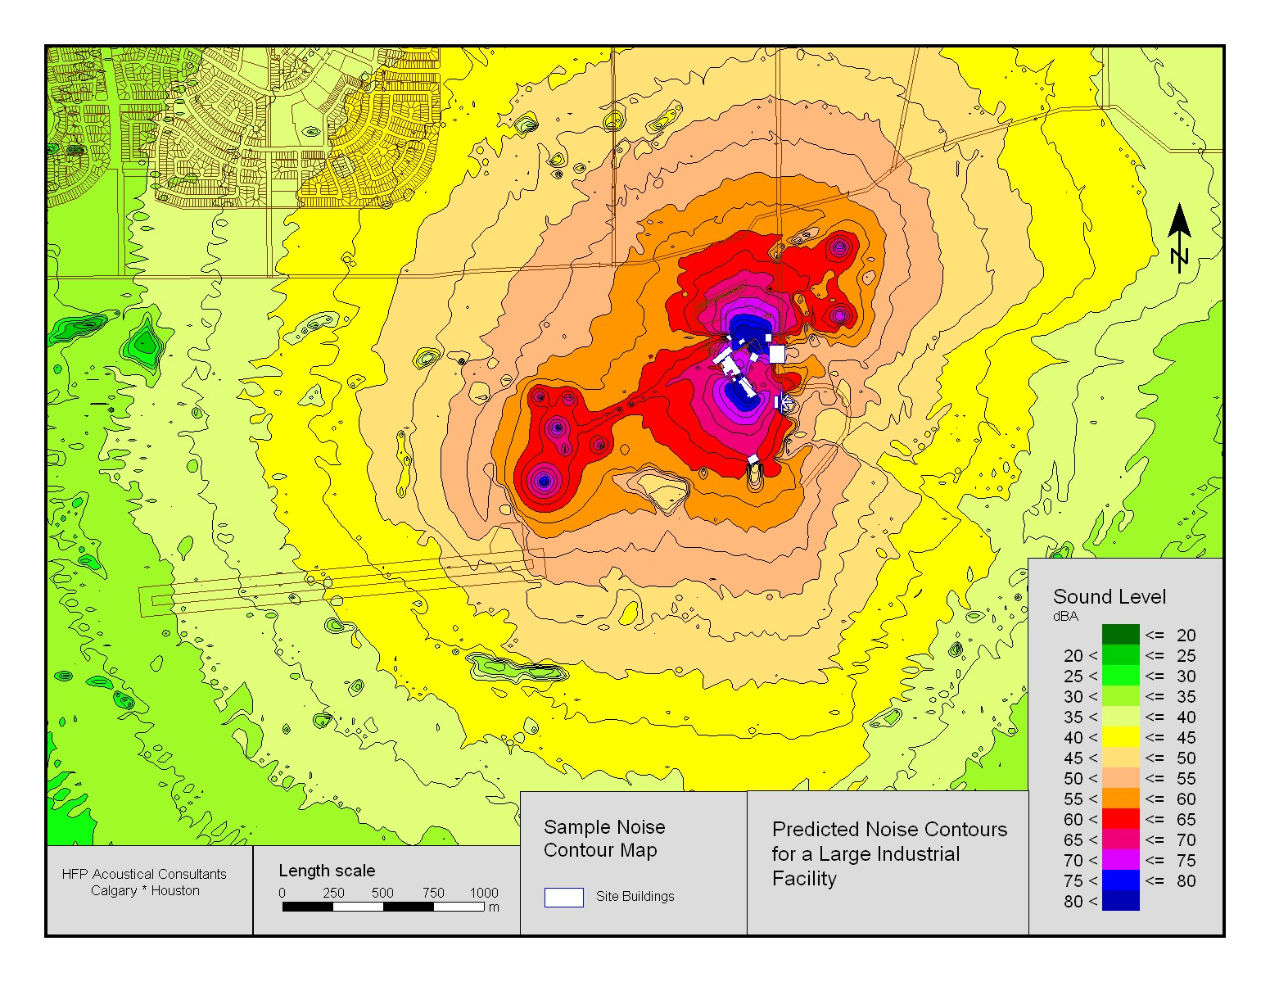
The output of a computer noise modeling can be isopleths as presented in color sound level contours. These isopleths provide an easy to read reference to community maps, for visualizing the potential noise impact of a proposed facility. Two sample results of a computer noise model output (isopleths) for a compressor station and for a pipeline straddle plant are presented below.
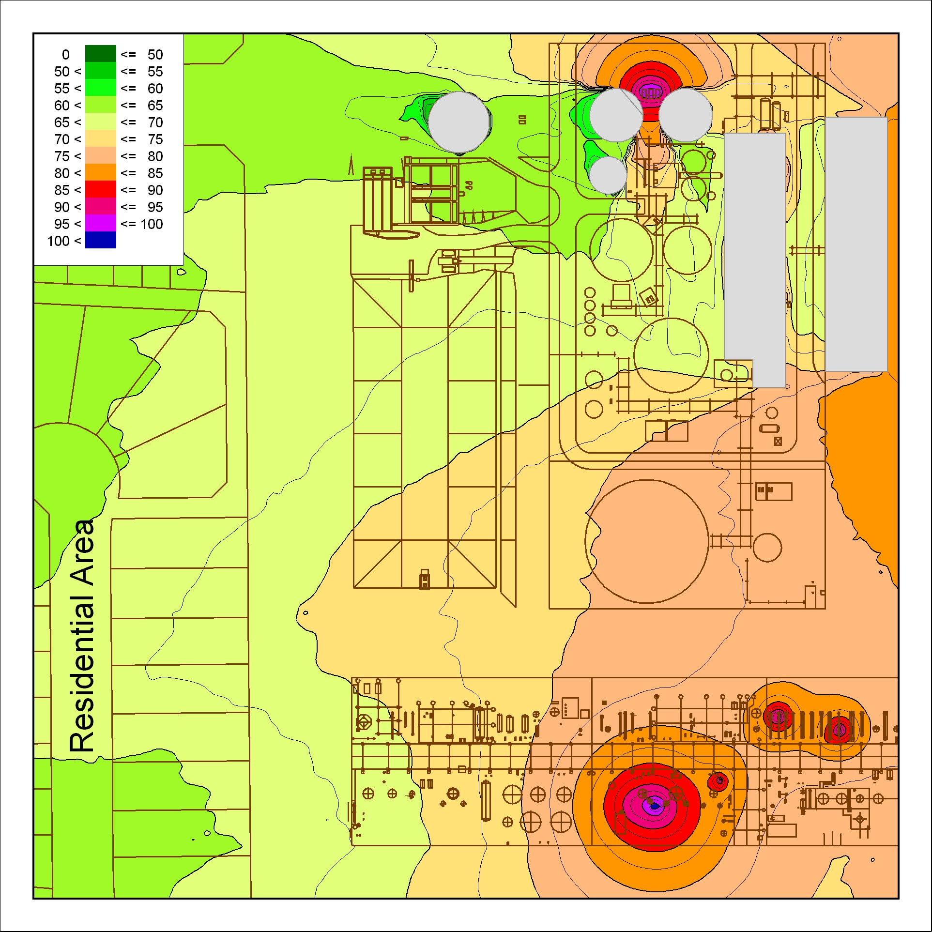
Then, the resultant calculations from the computer noise model also include a listing of each individual noise source's order-ranked contributions from the facility. This information is advantageous in determining priorities for noise control, as noise mitigation measures can be pre-selected for each noise source, and associated costs can then be estimated. Emphasis placed on modeling results can determine anticipated compliance to applicable regulations before acoustical treatments are applied.

Phase 4 – Design Noise Control Mitigation - specialty materials and systems: After identifying noise sources and conducting computer noise modeling, noise control mitigating measures can now be considered and incorporated into a facility’s design. Potential noise control designs typically include the following:
- Acoustical pipe lagging | - Acoustical performance specifications
- Acoustical blankets | - In-line compressor silencers
- Resilient pipe shoes | - Gas blowdown vent silencers
- Acoustical unit enclosures | - Quiet process control valve selection
  - Upgrades to building design (to provide sound absorption)
  - Upgrades to building panel construction (to provide sound absorption)
  - Upgrades to building ventilation components (e.g. acoustical louvers).
  - Fin-fan exchanger high-efficiency axial flow fan selection and tip speed control (e.g. VFD)

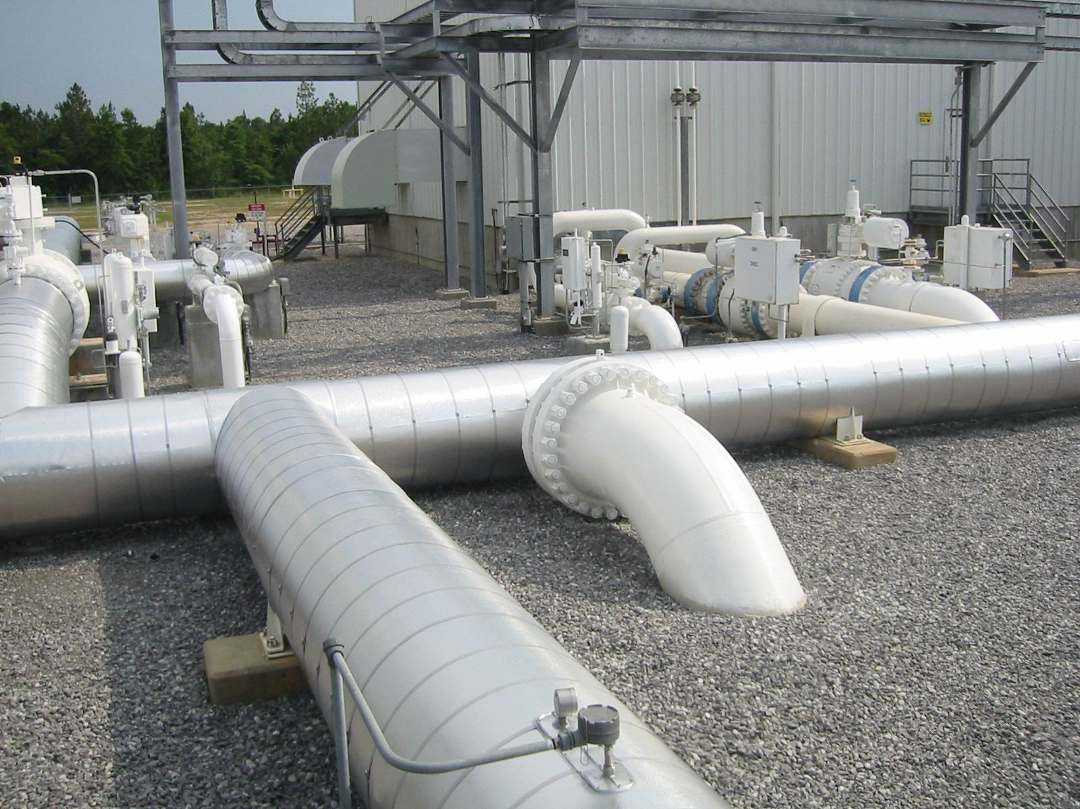
Some noise control requirements utilize specialized materials. For example, acoustical pipe lagging materials are utilized to attenuate piping noise at compressor stations. The insulating materials start with mineral wool insulation or with E-glass insulation, whereby a trade-off between the
Material’s acoustical performance and durability exists, and proper specification of the material’s density range allows the owner to obtain an optimized benefit. Similarly, the pipe lagging’s jacketing consists of two layers bonded together; consisting of a specialized impregnated vinyl sheeting and a common aluminum jacketing.

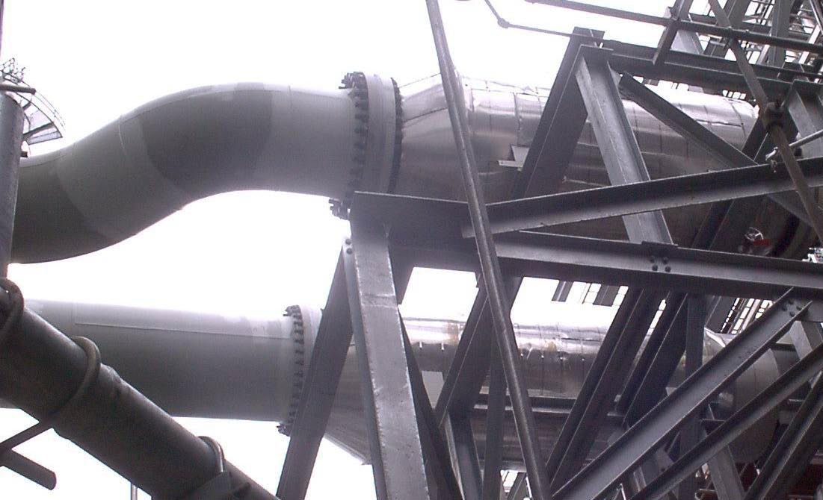
Other noise control requirements also utilize specialized systems. For example, noise from piping associated with gas turbine driven centrifugal compressors at compressor stations and pipeline straddle plants can be attenuated by utilizing in-line
acoustical silencers. Here, it is best to provide broad design requirements to specialized acoustical silencer vendors, as well as a clearly defined acoustical performance guarantee based upon on-site acoustical testing, so the silencer is built on a vendor-design / vendor-guarantee basis. Similarly, noise from compressor packages at compressor stations can be attenuated with acoustical rated compressor buildings. Here it is best to provide specific performance requirements to specialized acoustical compressor building vendors, again with a clearly defined acoustical performance guarantee based upon on-site acoustical testing.
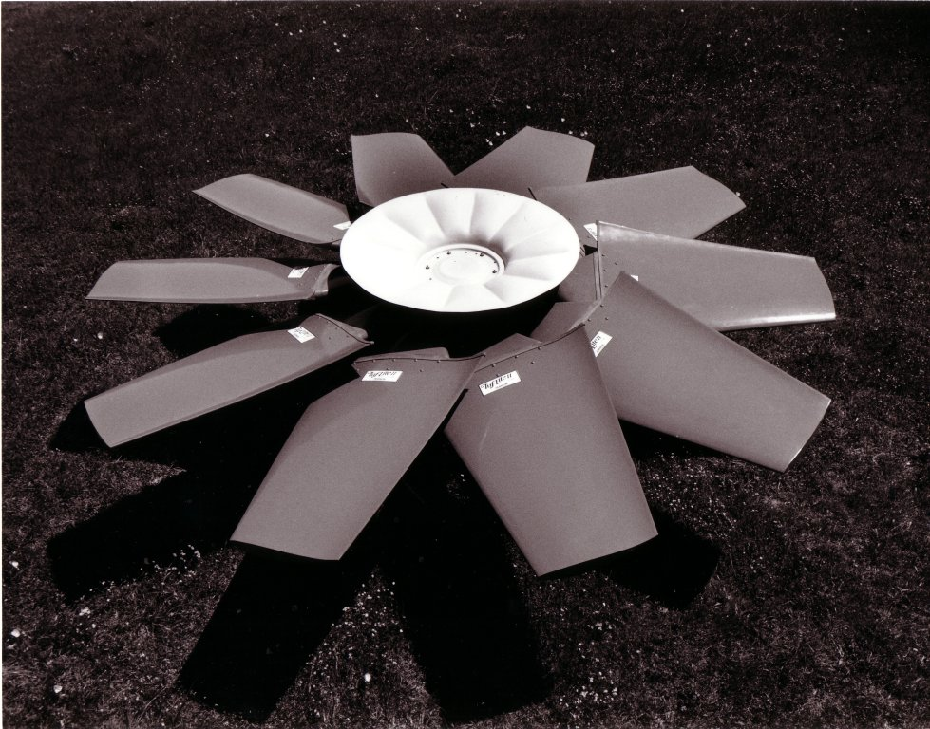
Phase 5 – Assess Cost-Effective Solutions - not interfering with operations and safety: The economics of facility design also plays an important role with acoustical engineering. For example, noise control from fin-fan exchangers at compressor stations can be optimized by selecting high-
efficiency axial flow fans to reduce the tip speed of the fan blades. The high-efficiency axial flow fans utilizing molded fiberglass can deviate from the shapes of conventional metal extruded fan blades. This allows for unique fan designs which have been proven to be more aerodynamically efficient as well as quieter. Furthermore, variable frequency drive (VFD) control systems are used to slow down the fan motors during times other than peak performance periods, providing both an operating energy consumption savings as well as reduced noise.

Phase 6 – Compliance: The final step towards demonstration that a project’s noise control engineering has worked to the project team’s satisfaction is to conduct compliance noise measurements at the nearby residences or NSA’s. As so much of meeting the intent of the design rests on predicting the facility’s sound level contribution at a residential location, the best proof is to demonstrate that compliance has been achieved. Yet one needs to be careful, as the state-of-the art of noise measurement can be a complicated expertise, including an understanding of sound propagation characteristics and knowledge of sound measurement instrumentation. Most important is being able to isolate out the sound of the facility from that of other ambient noise, such as from traffic, human activity and other industrial facilities. This is necessary because most regulatory requirements either specifically dictate or at least infer that it is the sound level contribution of the facility which must meet the requirements, and not that from other ambient noises. Many times 24-hour continuous noise monitoring is conducted, firstly to obtain a longer-term average, yet secondly to have sufficient data to be able to statistically isolate the facility’s sound level contribution.

Noise Control Optimization

Acoustical Unit Enclosures vs. Acoustical Rated Compressor Buildings: Various design alternatives exist to achieve the degree of noise control that is warranted. The choice between these design alternatives should be based upon practicality of implementation, the availability of specialized products, and cost. It is the noise control engineers’ responsibility to present these choices so that project management can make informed decisions.

One such common choice of a design alternative for turbo-compressor units is that of using either acoustical unit enclosures or acoustical rated compressor buildings. Close fitting acoustical unit enclosures provide a significant reduction of the gas generator and power turbine radiated noise, as well as the compressor casing radiated noise. Interestingly, the compressor casing is the quietest of the three components, so considerable costs can be saved by only enclosing the gas turbine’s gas generator and power turbine.

Unit enclosures are beneficial for operations personnel inside the compressor building; furthermore the unit enclosure will reduce environmental radiated noise as well. If the prime design criterion is to control in-plant noise from an occupational hearing loss prevention perspective, then utilization of an acoustical unit enclosure should be recommended. However, if the prime design criterion is to control environmental radiated noise to meet regulatory permitting requirements, then an alternative to using unit enclosures exists. This alternative is the utilization of an acoustical rated compressor building. This may represent a technically viable design alternative as well as a cost effective design alternative.

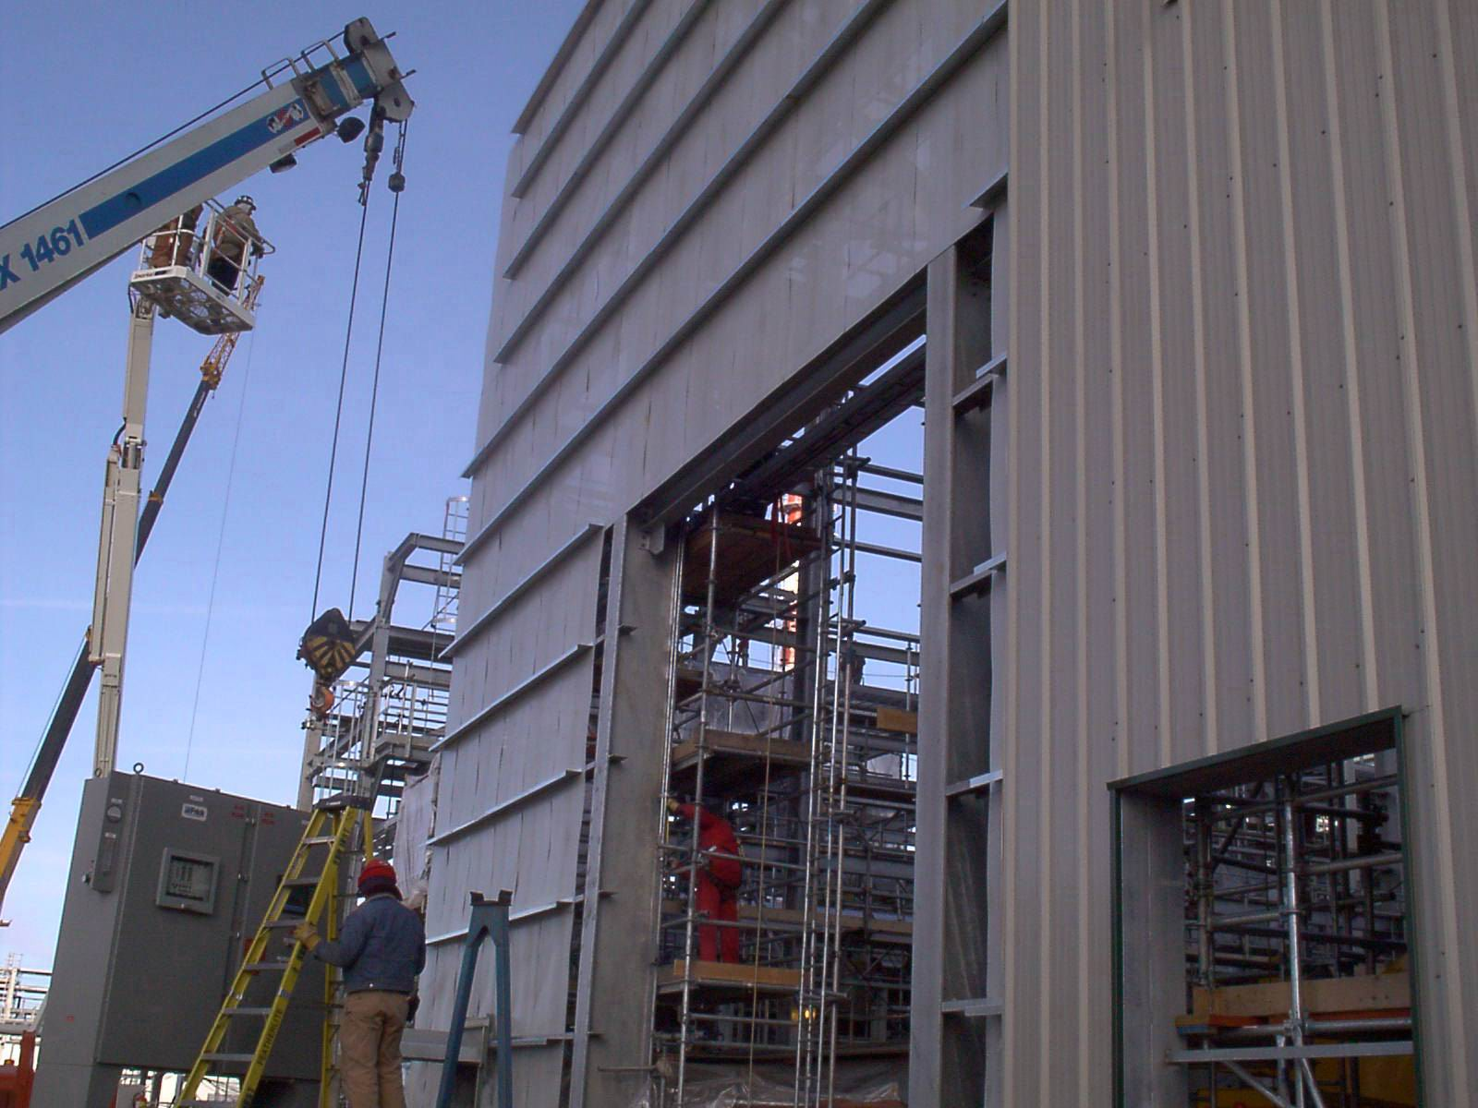
An acoustical rated compressor building can easily provide a significant degree of environmental benefit, and while the in-plant sound levels are higher, maintenance personnel save valuable time by not having to knock down enclosure walls for non-scheduled unit maintenance. And while unit
enclosures generally provide between 20 to 25 dBA of noise reduction, their benefit is limited to controlling just the noise from the gas turbine casing. Alternatively, acoustical rated compressor buildings generally provide greater than 30 dBA of noise reduction, and their benefit is also available to control noise from other noise sources such as interior piping and lube oil cooling skids. Both unit enclosures and acoustical rated buildings require silenced ventilation systems in differing proportions.

Obtaining a proper fit with an acoustical unit enclosure is imperative for it to work. Many O.E.M. turbo-compressor packages can be procured with an acoustical unit enclosure, where all of the design details have previously been worked out. This presents a greater reliability that minimal noise leakage radiation from the unit skid to the outside of the enclosure has been handled as appropriately as possible. Similarly, utilizing an acoustical rated building procured from a compressor building vendor that has successfully developed this special product will increase the likelihood that the entire building envelope will perform in a balanced manner. Conversely, it is not recommended utilizing a preferred building vendor who can not demonstrate understanding and experience with acoustics.

Balanced Noise Control Proportions: Noise source contributions from all mechanical equipment components also need to be reduced in balanced proportions to notice the effect of the casing radiated noise component as reduced by unit enclosures or acoustical rated buildings. Dominance of the gas turbine’s casing radiated noise contribution as compared to the power turbine’s exhaust noise contribution usually diminishes at distances greater than one-half of a kilometer away. Then for residences more than two kilometers away, the exhaust noise contribution is usually the sole remaining contributor. This infers that balancing the exhaust silencer’s performance with the casing noise reduction provides various economically balanced alternatives. Computer noise modeling clearly demonstrates these effects for various degrees of benefit of each, yielding a total acoustical balanced design.

Advanced computer noise models can tabulate an order-ranking of noise sources as they affect specific noise sensitive locations. This ranking capability allows the noise-control engineering effort to take a balanced design approach, one in which noise control dollars are allocated in the most economical manner. In many cases, relatively inexpensive treatment of secondary sources can produce a combined compressor station noise contribution which meets project noise goals. The following table is an example of an order-ranked list of a proposed compressor station's noise sources, with predicted sound level contributions before and after noise control treatments theoretically applied. The reader should note that the list of noise source contributions are order-ranked in the right-hand column, representing their prioritized affect after noise control, meaning that they are presented in descending order. The attenuated noise source contribution for yard piping is shown in orange (located extreme left side of the last column); the attenuated contribution for one engine exhaust is shown in green (left-centre); the attenuated contributions for cooler intakes and discharges are shown in purple (centre); and the attenuated contributions for compressor building panels are shown in blue (right-centre). Furthermore, the other three engine exhaust contribution values as shown in [ black brackets ] (right) were unchanged, as no noise control was needed on these noise sources. This type of balancing yields an optimized degree of noise control.

Noise Source Description | Before Treatments (dBA at NSA) | After Treatments  (dBA at NSA)
Yard Piping | 53.2 | 39.5
Unit 4 engine exhaust | 58.4 | 39.2
Unit 1 cooler intake | 55.1 | 38.7
Unit 2 cooler intake | 54.8 | 38.3
Unit 3 engine exhaust | 38.2 | [38.2]
Unit 2 engine exhaust | 37.8 | [37.8]
Unit 1 engine exhaust | 37.5 | [37.5]
Unit 1 cooler discharge | 55.7 | 35.9
Unit 3 cooler intake | 50.4 | 35.6
Unit 4 cooler intake | 49.5 | 35.1
Unit 2 cooler discharge | 47.8 | 34.0
North side of compressor bldg | 43.6 | 32.9
Unit 3 cooler discharge | 45.1 | 31.6
Unit 4 cooler discharge | 40.8 | 29.7
Roof of compressor bldg | 38.1 | 29.4
West side of compressor bldg | 35.2 | 29.1
South side of compressor bldg | 32.8 | 19.0
East side of compressor bldg | 29.8 | 17.0
Sum of Above Noise Sources: | 63.9 | 48.6

Strategies to Achieve Compliance to Regulatory Targets: Differing regulatory targets for achieving compliance to environmental regulations apply for compressor stations within the Canadian and American natural gas transmission industry. In Western Canada, the Alberta Energy and Utilities Board (EUB) enforces their noise control Interim Directive, ID 99-08, which controls the noise from industrial presence at neighbouring residences. The Permissible Sound Levels vary from 40 to 56 dBA L_{eq} during the nighttime hours. Similarly in Eastern Canada, the Ontario Ministry of the Environment (MOE) enforces their Noise Assessment Criteria in Land Use Planning, Publication LU-131, which controls the noise from stationary sources at an outdoor point of reception. The Sound Level Criteria vary from 45 to 50 dBA L_{eq} during any one hour. Then, in the United States, the Federal Energy Regulatory Commission (FERC) enforces their Title 18 Conservation of Power and Water Resources regulation, which controls the noise from compressor stations and other facilities involved in interstate transmission of natural gas at Noise-Sensitive Areas (NSA). The maximum allowable sound level contribution at the nearest pre-existing NSA is 55 dBA L_{dn}, which is equivalent to 48½ dBA L_{eq} during the nighttime hours.

The preferred strategy to achieve compliance to these regulatory targets is always to utilize the balanced noise control design approach, as discussed above. The use of computer noise modeling as a tool to test these conceptual designs is certainly advisable. The intent is to produce a balanced design, which on paper, yields an optimal extent of noise control. This optimal design is not under-designed so that the criteria will not be met, and is not over-designed so that unnecessary excessive expenditures are made.

Drawbacks to Successful Implementation

Be Aware Of Individual Sensitivities: In many cases, the environmental noise regulatory requirement’s numerical limit (e.g. 50 dBA L_{dn} at the residence) is used as the goal for noise control. It is practical to have a referenced number to shoot for, but this is not a substitute for using common sense and experience when setting the noise target for a project. People vary widely in their individual sensitivity to noise, and attitudes depend on the absolute and relative sound level of new noises. Annoyance is also affected by the sound frequency, tonal characteristics, temporal variations (on/off cycles), nature of the source, previous exposure to environmental noise, and time of day. Because of the wide variation in potential annoyance, there is no guarantee that neighbouring residents will not complain (or file a lawsuit) about noise, simply because a facility is in compliance with all applicable regulations. In many cases, there are no federal, provincial, state, or local noise limits at all; yet that does not mean that it is safe to ignore noise control. Regulations and guidelines can be used as an initial basis for assessing the need for noise control, but ultimately it is important to carefully consider the environmental noise consequences of any new facility or equipment modifications. Remember, every situation is different.

The Myth of 85 dBA: Acoustical engineers have developed several hundred computer noise models in the past decade. The input data used for compressor station equipment comes from a variety of sources, including on-site noise measurements, estimates based on similar equipment, and manufacturer noise data. Some equipment manufacturers have compiled accurate and detailed sound pressure level data for their equipment; yet many others do not have adequate noise data. A few decades ago, OSHA established 85 dBA as a goal for occupational noise exposure, based upon a time-weighted average for an 8-hour daily exposure. Although this goal was not intended to be directly applicable to machinery noise limits, that 85 dBA numerical value has become entrenched as the claimed noise level produced by many types of industrial equipment – large or small. If a manufacturer claims that his equipment produces exactly 85 dBA at 3 feet, it might be a realistic value, or it might be wishful thinking. Experts have learned to be suspicious of any piece of compressor station equipment that is rated at 85 dBA.

Don’t Specify Without Acoustical Performance Guarantee: When adopting the concept of vendor-design / vendor-guarantee, the compressor station designer and owner need contractual assurance that an engineered noise control system or product will perform. The common pitfall is to accept a vendor’s guarantee that the noise from their product will not exceed a certain sound level at a certain distance. Unfortunately this leaves may avenues of escape open, such as “it met the test requirements in our shop”; or “it was not our equipment making the extra noise”; or “we are not responsible for reverberant noise in your building”; or “just shut down all the equipment nearby and then we will measure ours independently (knowing this is not possible)”; or “we are not responsible for it being louder given the wind direction”; or even “it was the road traffic making the noise at that distance”. The suggested answer is, firstly, to specify an acoustical performance test procedure, which utilizes on-site measurements, that isolates the sound pressure level contribution of the equipment that will be tested from all other extraneous noise contributions. Secondly, clearly define, negotiate and agree on the noise isolation measurement technique and analysis procedure at time of bid, so there are no avenues of escape afterwards. Thirdly, make sure the equipment vendor knows your intention to conduct the performance guarantee noise measurements, and that the vendor will be invited to witness those measurements.

Management Buy-in: Generally, as project management is in charge of procurement costs, very little can be accomplished if there is a lack of appreciation of the value and the need for having noise control and to ensure that the noise control program is being implemented. Even though project engineers and acoustical experts work hard to evaluate noise control treatments, the value and the payback from noise control is viewed as an intrinsic commodity that is hard to directly identify. However, the down-the-road payback can be real in terms of reducing environmental regulatory approval time and costs, reducing hearing loss claims, and reducing future retro-fit projects. Other less measurable benefits include keeping neighbours happy and increased operator satisfaction due to a quieter working environment. Therefore, it is very important to have project management approval or "buy-in" for noise control efforts, with specific design targets announced, so that the acoustical design can be successfully implemented.

Conclusions

Designing for and achieving noise control incorporates complex procedures which in many respects can be handled as a separate design discipline. As noise control is a state-of-the-art science, where many individuals are available having significant experience and who are available to help on projects, utilizing these experts can provide enhanced technology to assist in compressor station environmental noise control design efforts.

